Lab 2
T-Flipflop (4 bit)
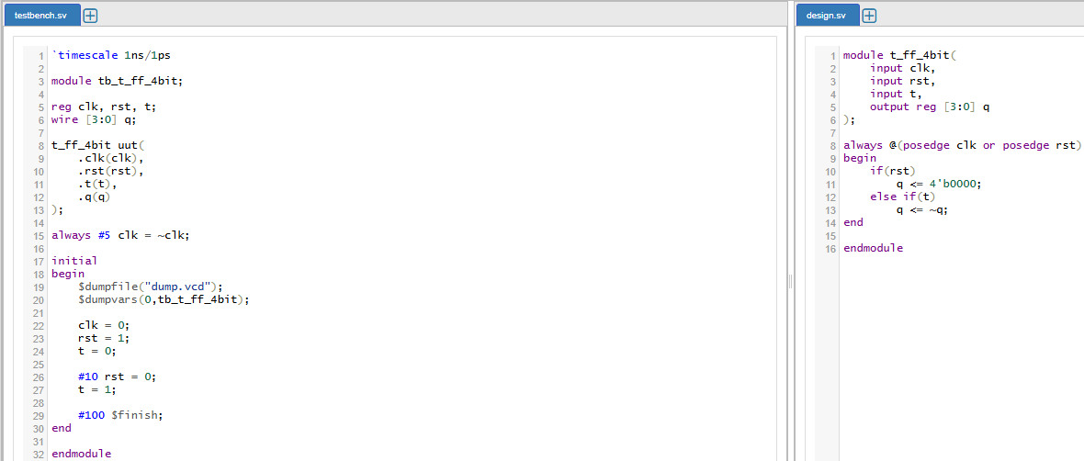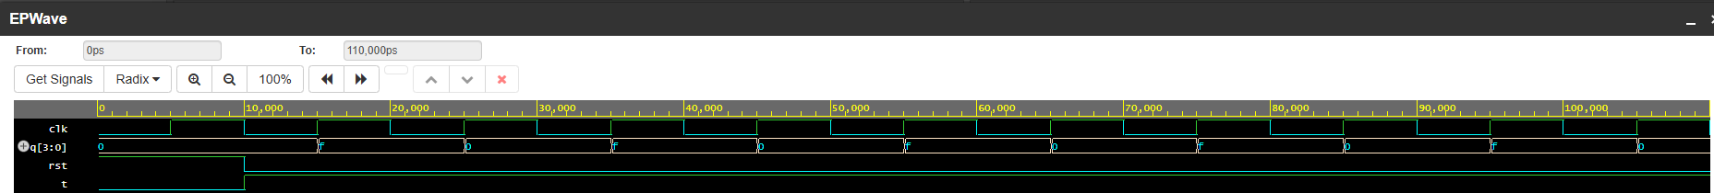
4 Bit Up Counter Synchronous
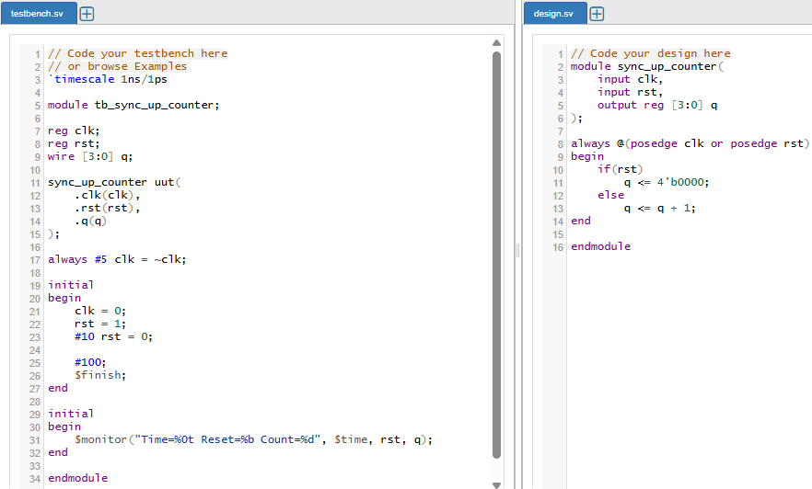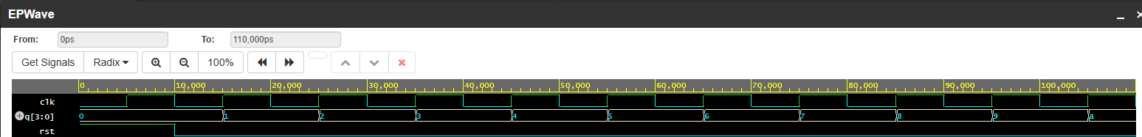
4 Bit Down Counter Synchronous
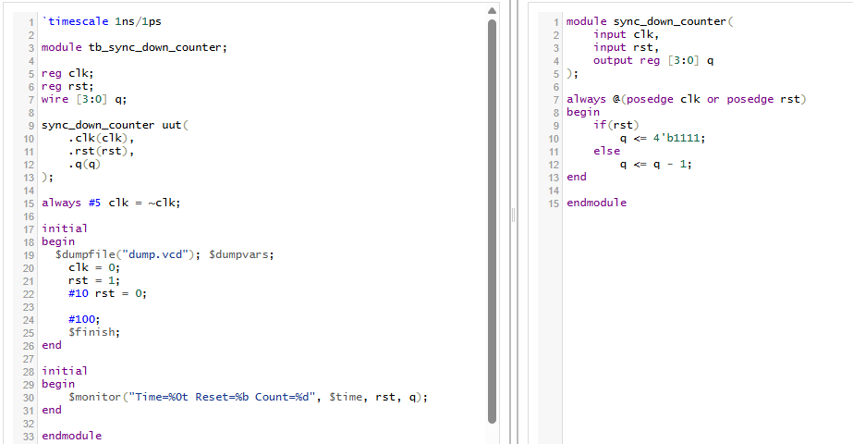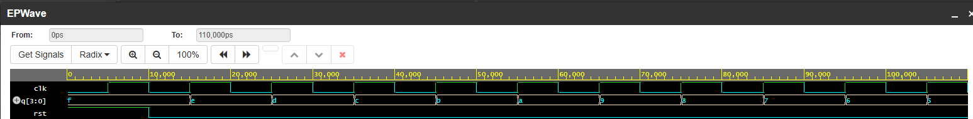
4 Bit Up Counter Asynchronous
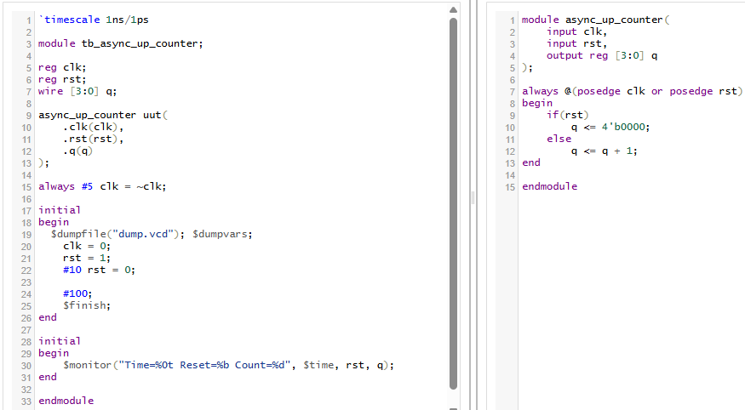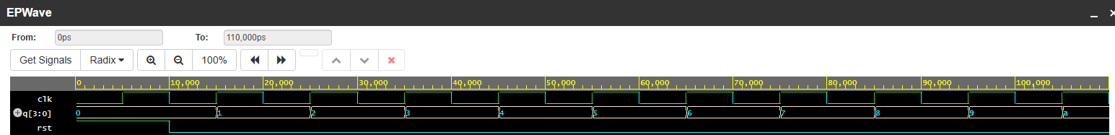
4 Bit Down Counter Asynchronous
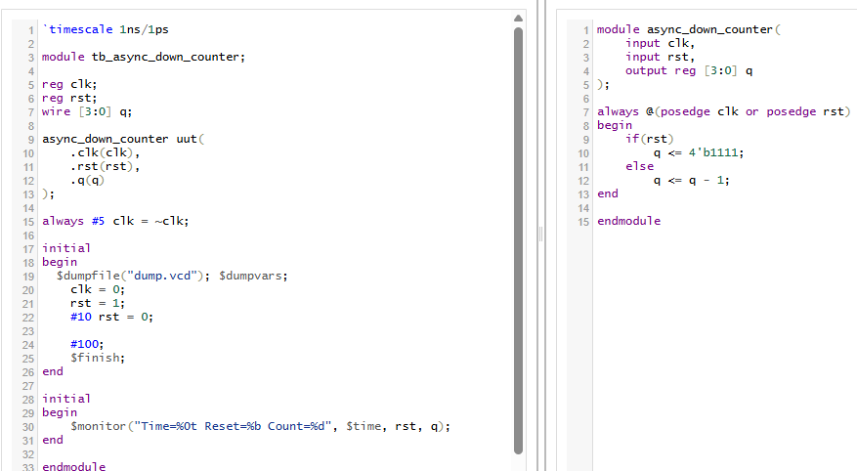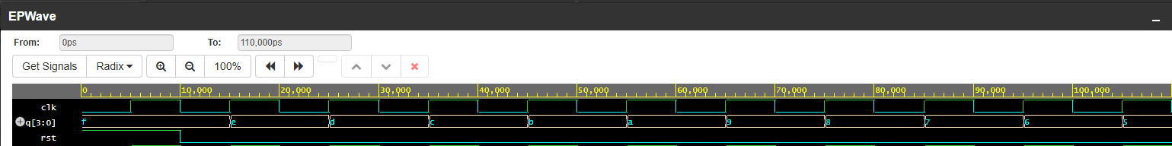
BCD Counter
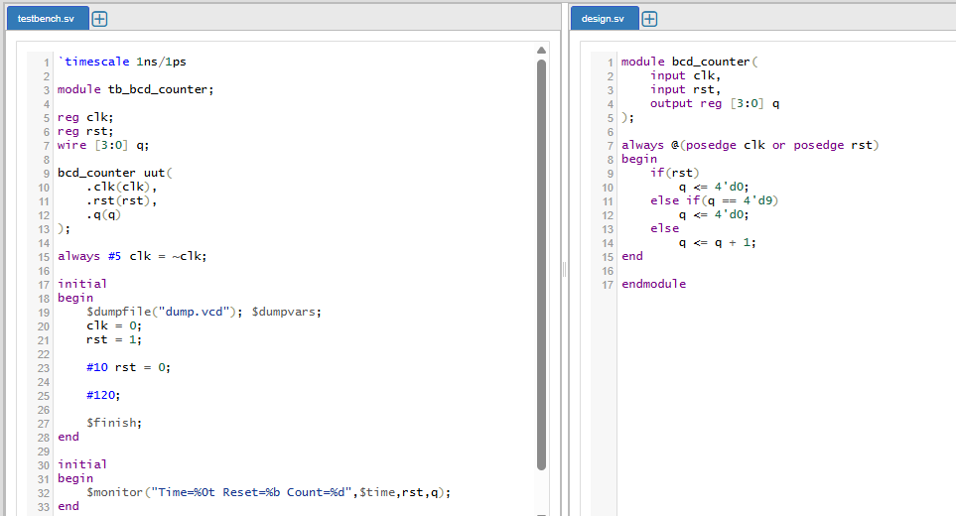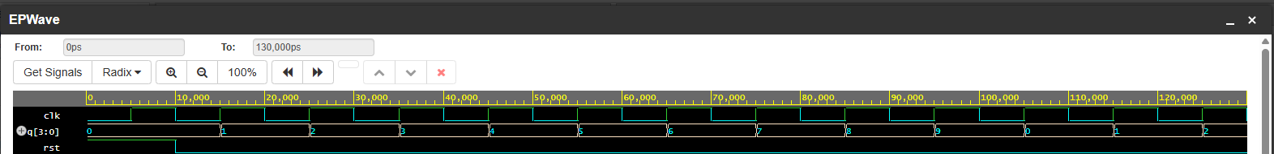
Mod-n-Counter
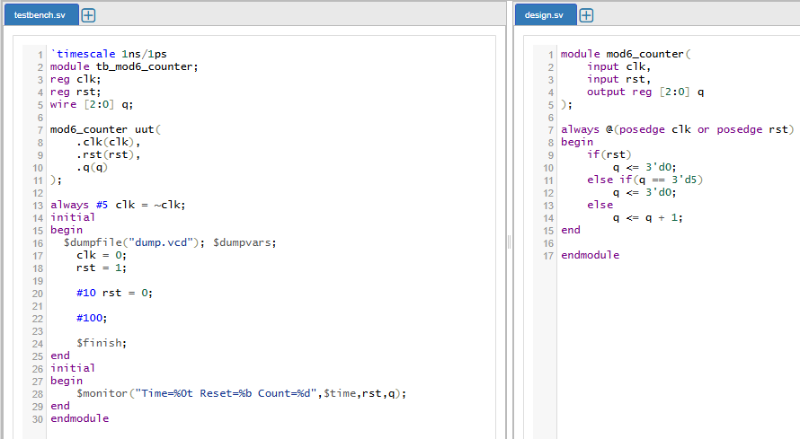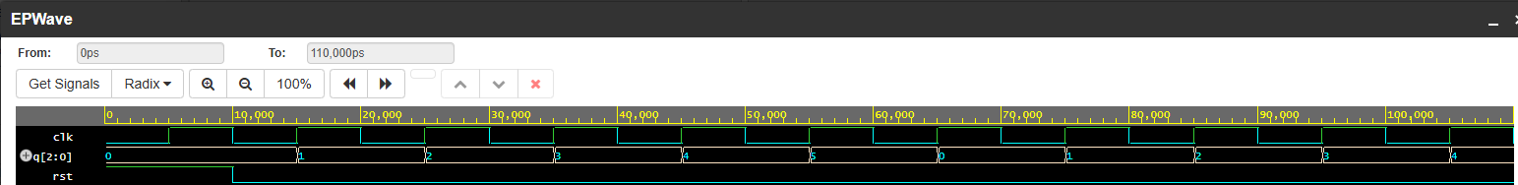
Frequency Division (100 MHZ - 25 MHZ)
